**Question 1:**

create table db1.login2 as

select *,week(login_time) as weekno,lead(login_time) over(partition by user_id,week(login_time) order by login_time) as next_login,

timestampdiff(minute,login_time,lead(login_time) over(partition by user_id,week(login_time) order by login_time)) as min

from db1.login order by 1,2,3 ;

select weekno,count(user_id) as users from (

select *, dense_rank() over(partition by user_id,weekno order by login_time) as row_num from db1.login2) as tb3

where row_num=1 and min>=10 and min<=360 group by 1;

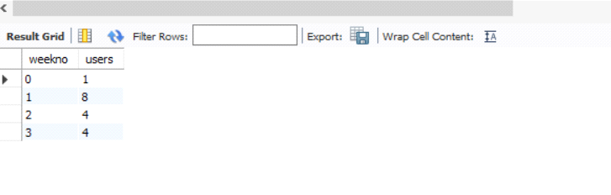

**Questions 2:**

create table db1.login3 as

select *, dense_rank() over(partition by user_id,weekno order by login_time) as row_num from db1.login2;

select * from db1.login3;

select weekno,(sum(case when row_num=1 and min>=10 and min<=360 then 1 else 0 end)/count(distinct user_id))*100 as total_per

from db1.login3 group by 1;

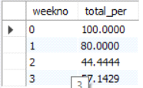

**Questions 3:**

select t6.weekno,(t5.sec_user/users)*100 as q3_per from

(select weekno,count(distinct user_id) as sec_user from (

select * from db1.login3 where user_id in (select user_id from db1.login3 where row_num=1 and min between 10 and 360)

and weekno in (select weekno from db1.login3 where row_num=1 and min between 10 and 360)

and row_num in (2,3,4)) as tb4 where min between 10 and 360 group by 1) as t5

join

(select weekno,count(user_id) as users from (

select *, dense_rank() over(partition by user_id,weekno order by login_time) as row_num from db1.login2) as tb3

where row_num=1 and min>=10 and min<=360 group by 1) as t6 on t6.weekno=t5.weekno;

